# Lab1

## Name: Zeng Yuhang

## ID: 222320008

Part1

1. Create a topology in figure

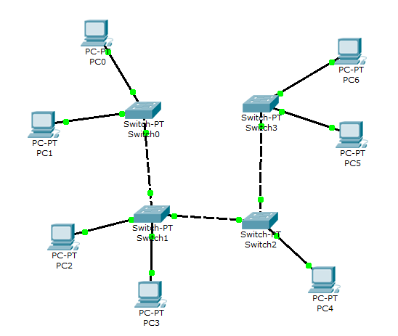

1. Assign addresses to computers, according to option “v”. “v” – is your last digit of your HDU ID.

My ID finishes with 8. So, the IP address of computers is 80.8.1.X. X is the same as the X in PCX, except PC0. Because 80.8.1.0 is the address of this network. Thus, I assign IP address 80.8.1.7 to PC0.

1. Run the ping utility, according to the table.

My job is ping PC5 from PC6.

1. In “simulation Mode”, track the movement of packets and protocols used.

First, PC6 sends ARP protocol packet to find PC5. Switch3 accepts the packet and transmit to other ports. PC5 accepts the packet and return ARP protocol packet to PC5. So that the devices on the path from PC6 to PC5 know how to transmit a packet to PC5. Then, PC6 starts to send ICMP protocol packets of the Ping command, and PC5 return the ICMP protocol packets. There is some STP protocol packets send from Switch0 to all other devices, I’m not sure what these are and what purpose they want to attain.

1. Switching to “Simulation Mode” to review and explain the process of data exchange over the ICMP Protocol between devices (by executing the Ping command from one computer to another item. Include a detailed explanation in the report.

PC6 ping PC5 via IP address. This is Layer3’s work. In Layer2, PC6 will send to the MAC address of Switch3 because this is the only one it can reach. Then, Switch3 find the IP-MAC table inside itself and transmit it to the MAC address of PC5 directly. Next, PC5 receives and changes the source and destination of both IP address and MAC address, sending new packet to Switch3. Finally, Switch3 checks the IP-MAC table again, transmit to PC6 and PC6 receives. The process repeats 4 times.

1. Make sure that all network objects are reachable using the IP Protocol.

Yes, I do.

1. Make screenshots and add to report. Write your explanation on item5.

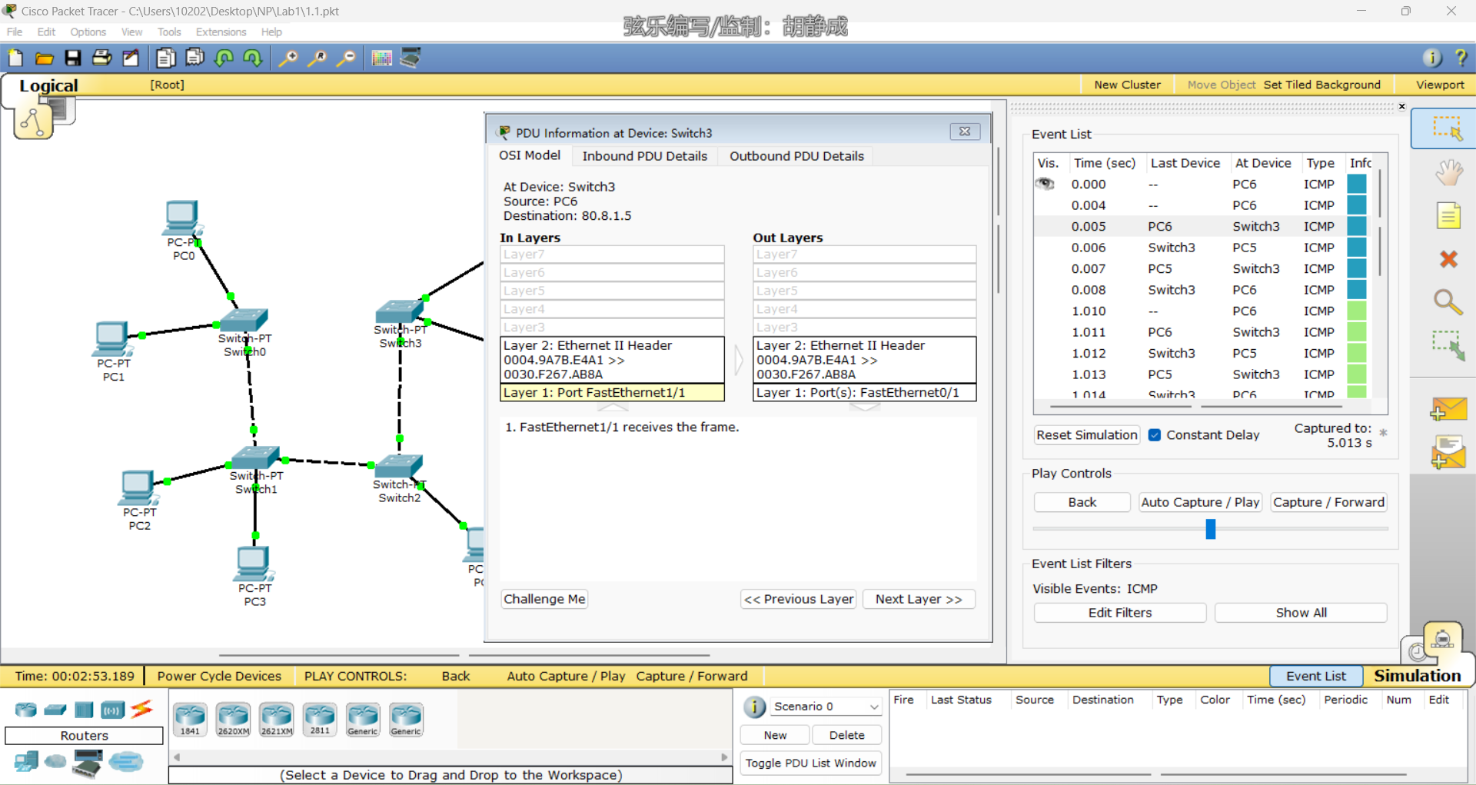

Question

1. What is difference between hub and switch?

Hubs and switches are both networking devices used to connect multiple devices to a network, but they differ in the way they handle network traffic. A hub broadcasts all network traffic to all devices, while a switch only sends network traffic to the device that is intended to receive it.

1. What layer of OSI model is used for the switching?

Switching is a function that occurs at the data link layer (Layer 2) of the OSI model.

1. Describe the aims of subnet mask?

The main aims of the subnet mask are to identify the network portion of an IP address, divide a network into subnets, conserve IP addresses, and assist in routing.

1. Do we have one subnetwork or 4 (because we have 4 switches)? Explain.

There is only one subnetwork. Because all the switches are connected to each other and to the same network segment.

1. What will happen if we will change the address of PC6 to v*10.v.2.6 and make ping request from PC1 to PC6? Is it successful or not? Explain, please, why?

PC1 would not be able to reach PC6 via a simple ping request. Because PC6 is assigned an IP address outside the network range of 80.8.1.0/24, and PC1 would therefore send the ping packet to its default gateway (assuming it has been configured with one). The default gateway would then try to forward the packet to the correct network segment, but would not be able to do so since there is no route to the network segment where PC6 is located.

Part2

1. **Test 1: ping 192.168.5.3 from 192.168.3.4**

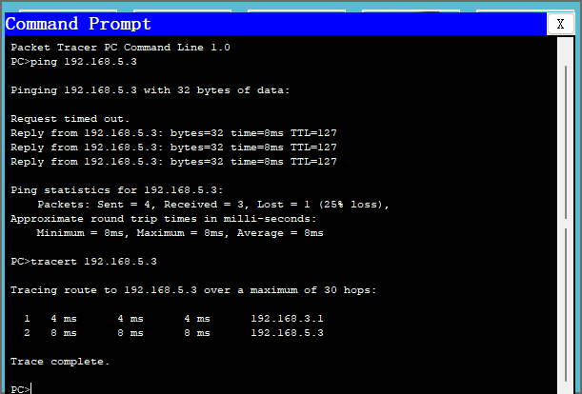

* 192.168.3.4 wants to send ICMP protocol to 192.168.5.3, but find that the destination IP is in the external network. So, 192.168.3.4 will send the ICMP protocol to the gate first. However, 192.168.3.4 doesn’t know how to get to the gate. Therefore, 192.168.3.4 sends the ARP protocol first to find the gate 192.168.3.1.   
  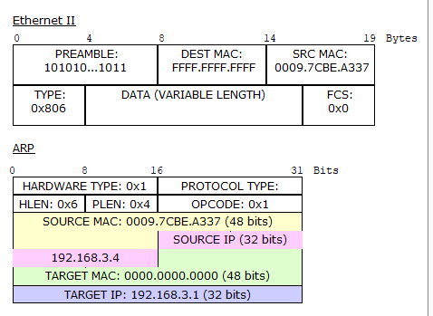
* Router0 receives the ARP protocol and sends the response (MAC address of gate 192.168.3.1) to 192.168.3.4.   
  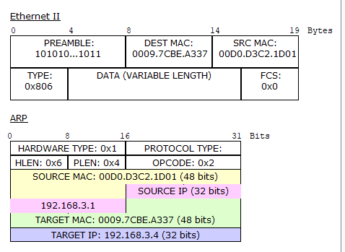
* 192.168.3.4 sends the ICMP protocol to the gate router first. ICMP type 8 is request.   
  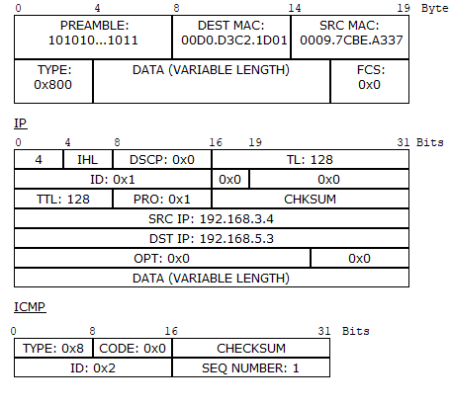
* Then the gate router transmit the protocol to the destinate network. However, the router doesn’t know how to reach 192.168.5.3. So, the router sends ARP protocol to find 192.168.5.3.   
  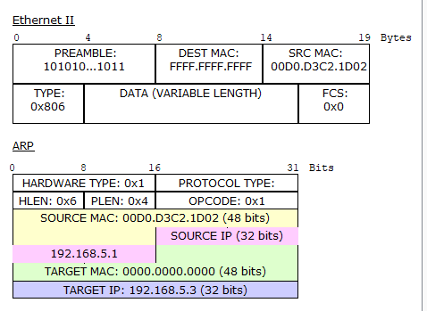
* 192.168.5.3 receives the ARP protocol and sends the response (MAC address of gate 192.168.5.3) to gate router 192.168.5.1.   
  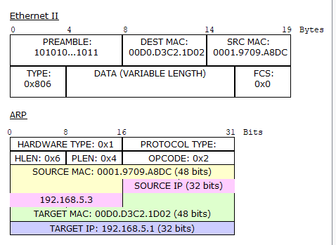
* 192.168.3.4 doesn’t receive the response of 192.168.5.3 in the limit time. So, the first ping request return ‘Request timed out’. After that, 192.168.3.4 sends the ICMP protocol again. ICMP type 8 is request.  
  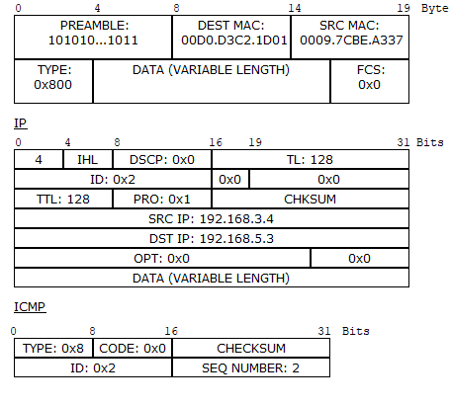
* The message is sent to Switch0 first, and Switch0 sends it to the gate router. Then, the gate router transmits it to the destinate network. After that, the message reaches 192.168.5.3 through Switch1 and 192.168.5.3 sends a response by the way the request came. ICMP type 0 is response.  
  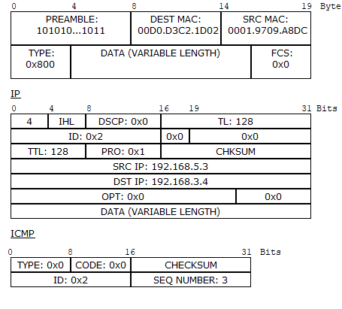

1. **Test 2: ping 192.168.3.4 from 192.168.3.5**

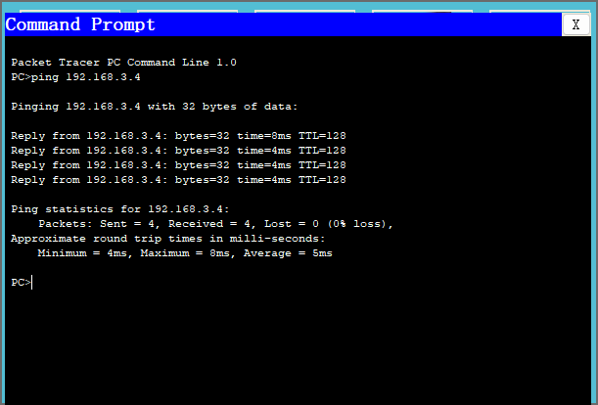

* 192.168.3.5 wants to send ICMP protocol to 192.168.3.4 in inside network. So, 192.168.3.5 will send the ICMP protocol directly to 192.168.3.4. However, 192.168.3.5 doesn’t know how to get to the destination. Therefore, 192.168.3.5 sends the ARP protocol first to find the 192.168.3.4.  
  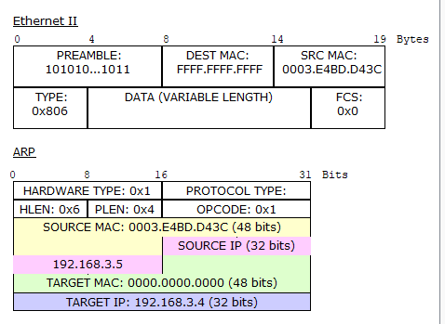
* 192.168.3.4 receives the ARP protocol and sends the response (MAC address of gate 192.168.3.4) to 192.168.3.5.   
  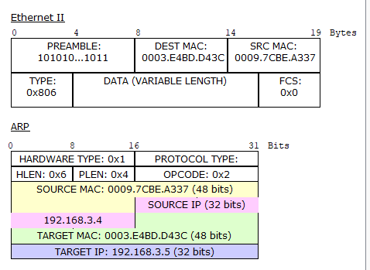
* 192.168.3.5 sends the ICMP protocol to 192.168.3.4 directly. ICMP type 8 is request.   
  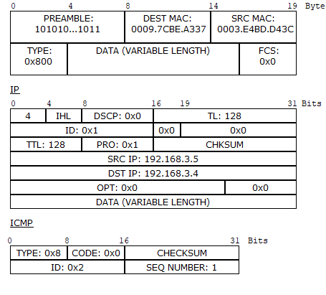
* The message is sent to Switch0 first, and Switch0 sends it to 192.168.53.4. After the message reaches 192.168.3.4 through Switch0, 192.168.3.4 sends a response by the way the request came. ICMP type 0 is response.  
  